IMAGE PROCESSING

PHASE-1

GROUP-1

Day 1- 28 NOV

We were told how to install Ubuntu. We had to download a version of Ubuntu(16.04), burn it on a pendrive using rufus and use that pendrive as a bootable drive.

Next we were told to install open source Computer Vision using a file which was sent to us.

Day 2- 29 NOV

How to open and changing some properties of image was taught.

Mat- It is a class which is used to contain the information of an image.

It requires 4 inputs first 2 being the dimensions of an image, 3rd

one is to define wether an image is greyscale or bgr format. And

Last one reads he shades.

imread- Used to read an input image and write it into Mat.

namedWindow- Creates a window for displaying image.

Imshow- Used to display the image in the given window.

Conversion of colour image to grayscale using average, maximum and minimum values, and a formula based on how much our eyes is sensitive to given colour was provided.

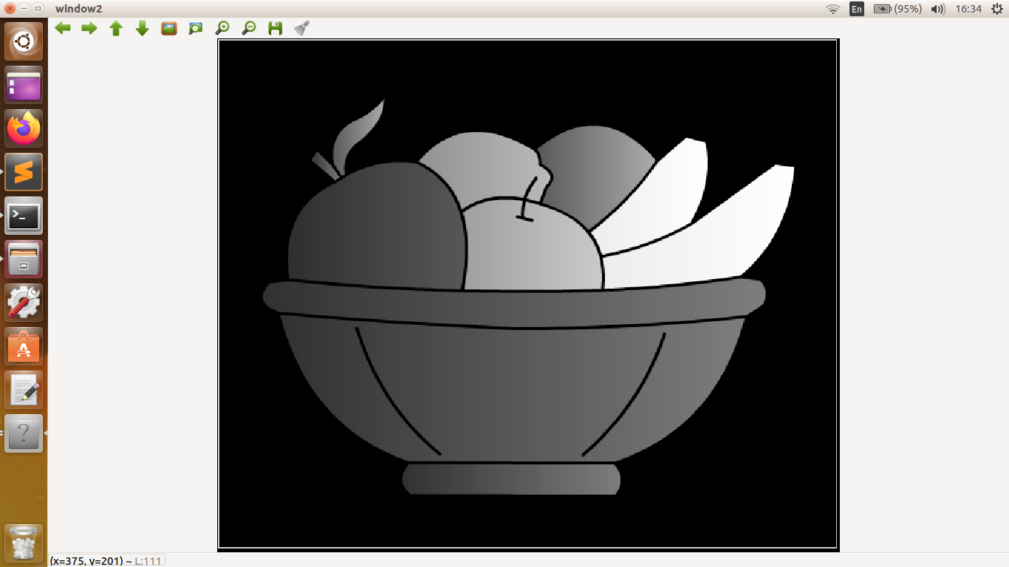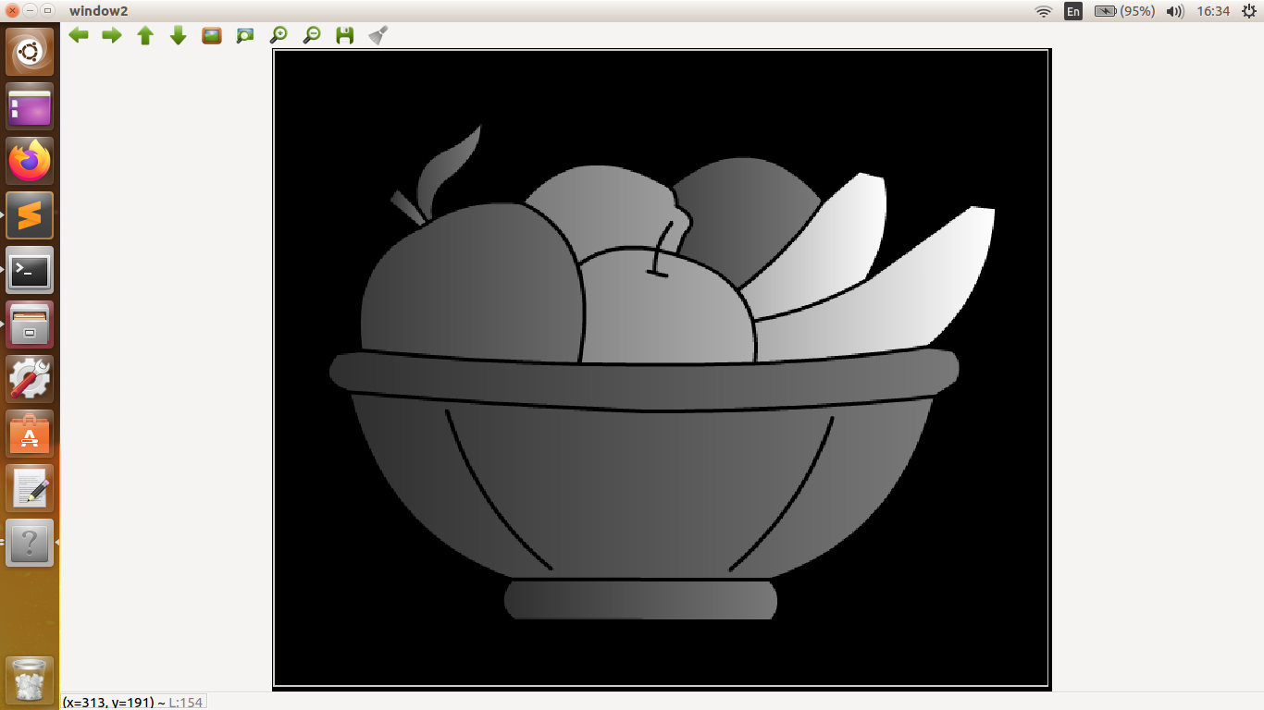

Greyscale by averaging. Greyscale using intensity=0.21R+0.72G+0.07B

We can also convert grayscale to binary by making pixels with intensity above some threshold white and rest black.

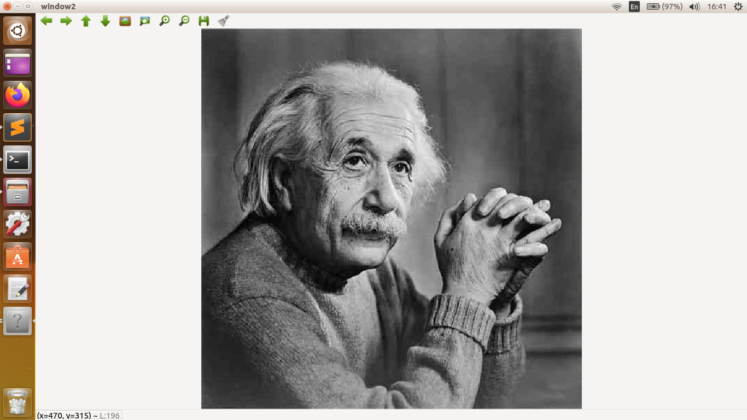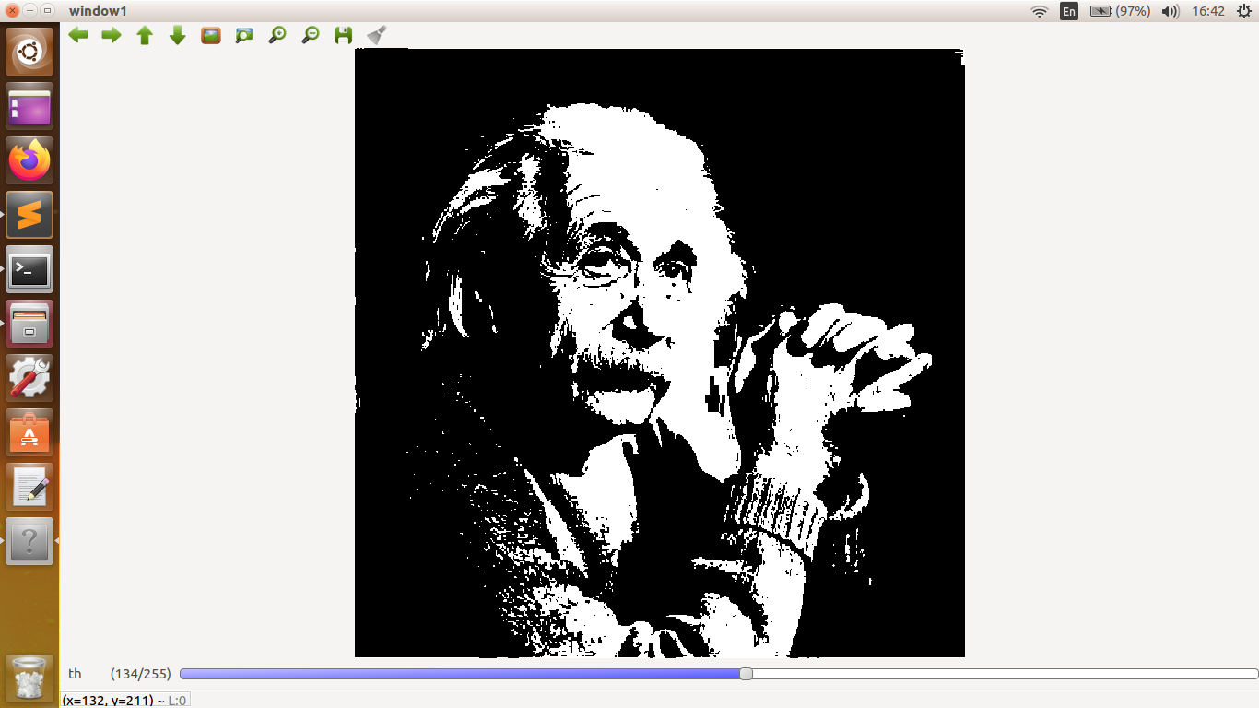

Original Image. Image after converting to binary.

Using these we were told to make a circle and chessboard.

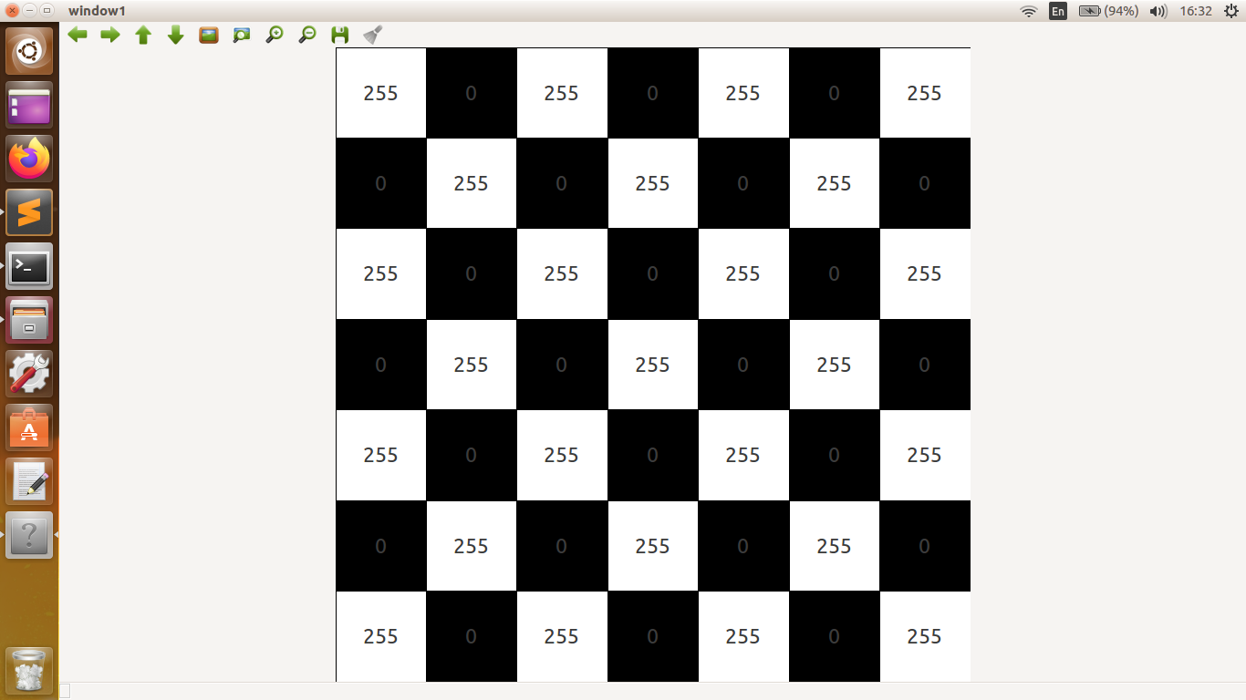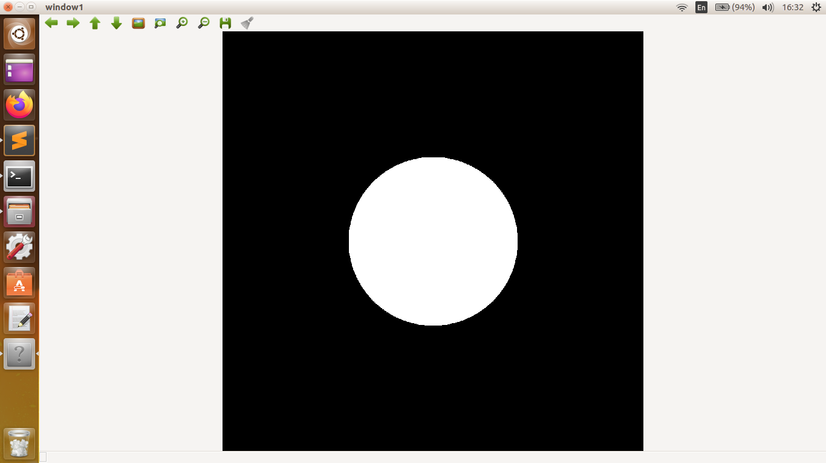

Mirror, rotation, and segmentation of objects was also done.

Segmentation-Taking out a part of image we are interested in.

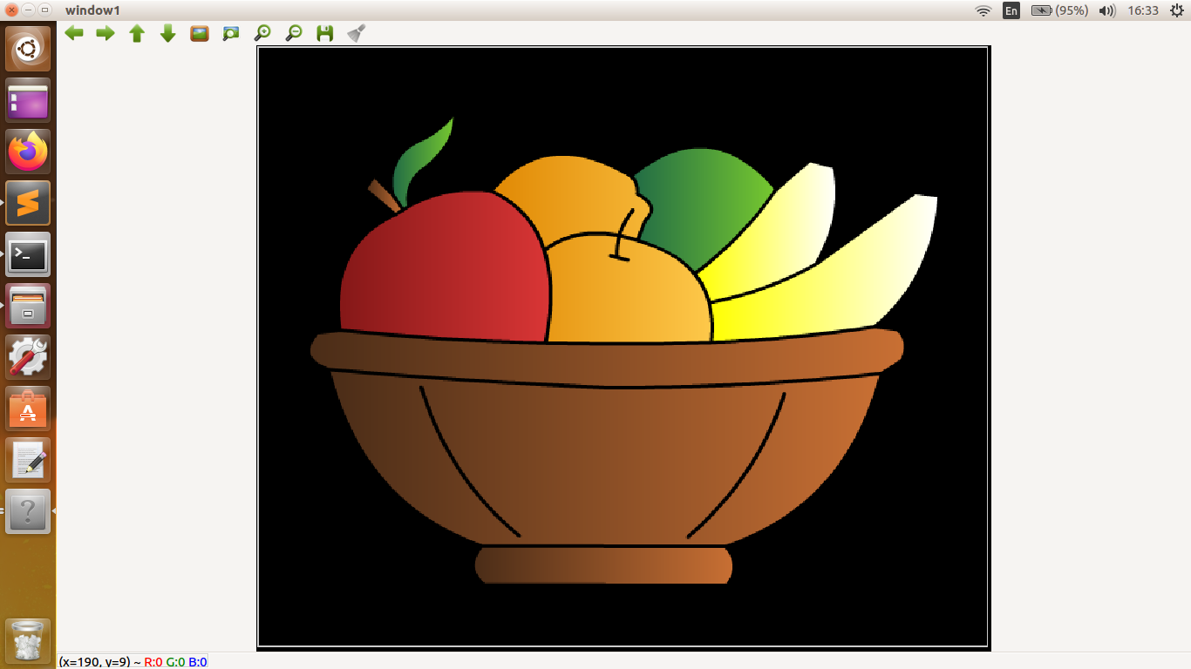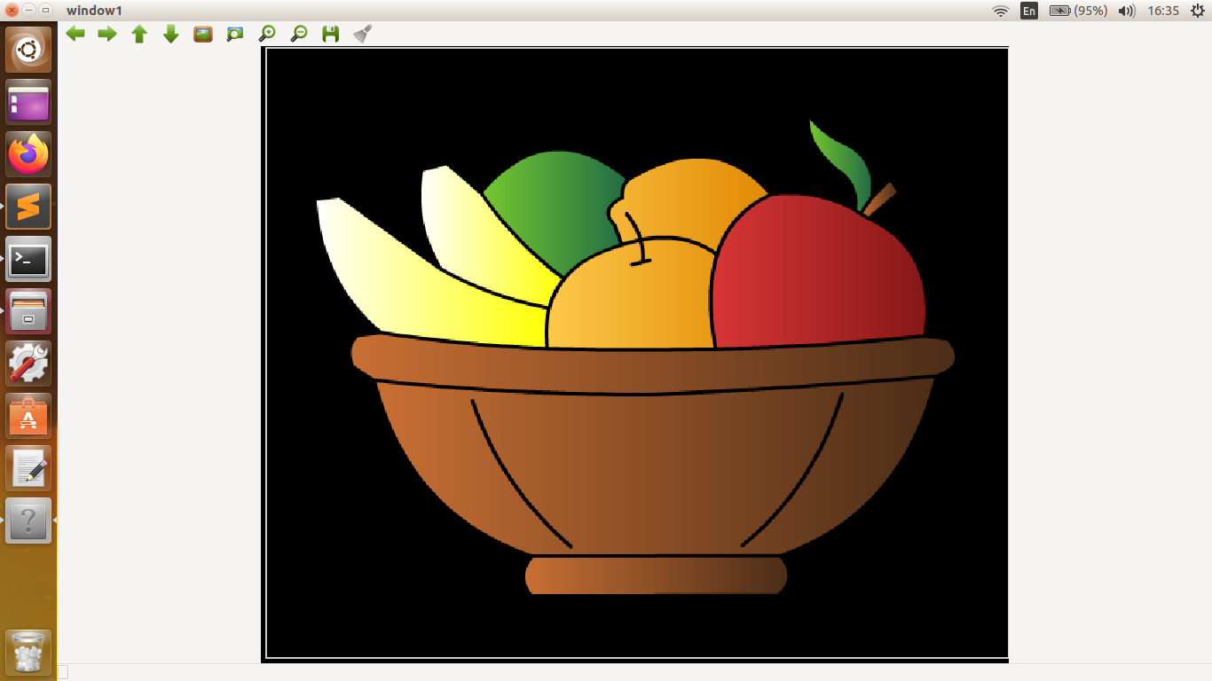

Original image. Mirror about vertical axis.

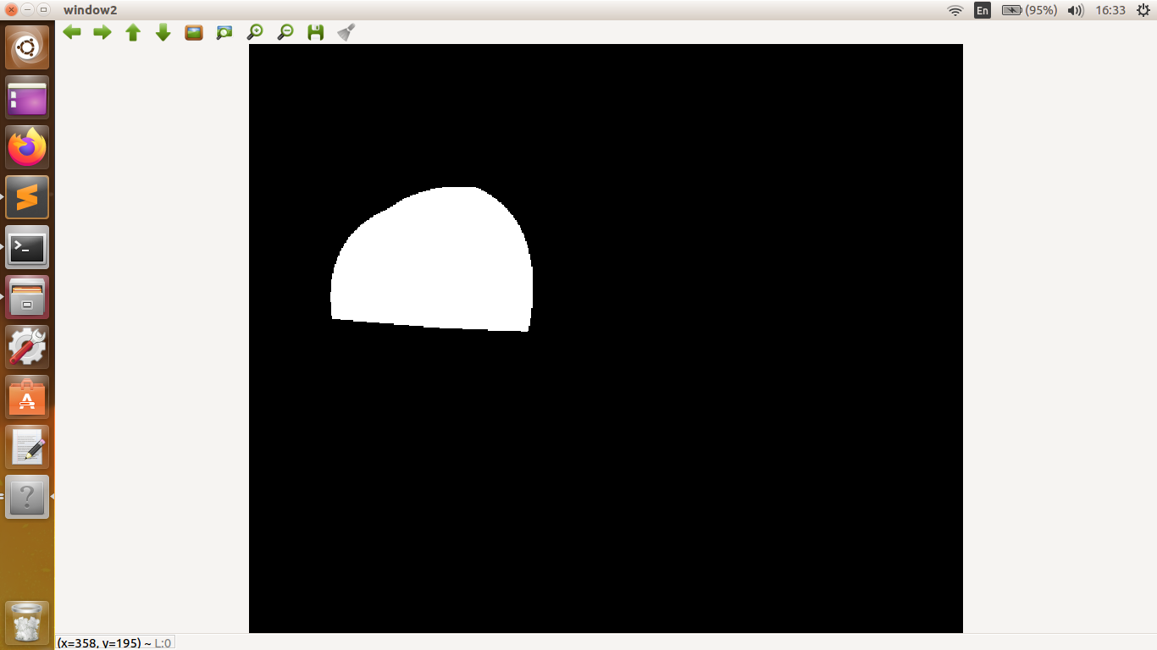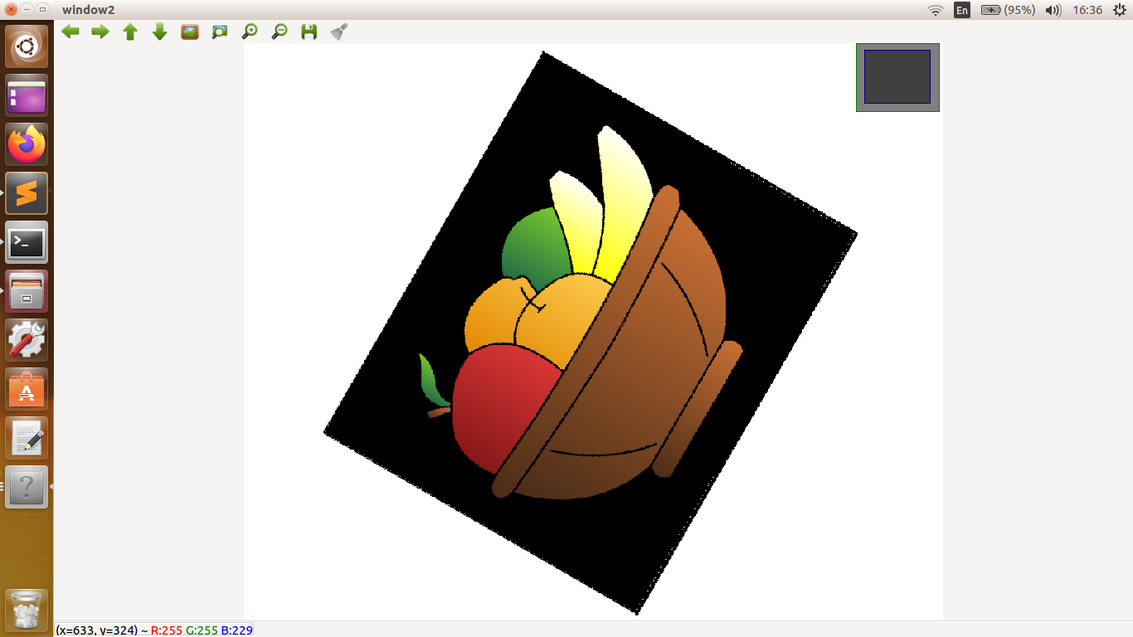

Rotated by 60 degrees(anti-clockwise) . Apple segmented out.

Day 3- 30 NOV

We were taught about kernel, erosion and dilation, convolution, mean median and gaussian blur, edge detection and using canny for that purpose. Histogram.

Kernel- Kernel is a small n\*n matrix, which is used for different purpose like blurring sharpening, edge detection etc. depending on the weighs in elements of kernel. It changes the properties of the pixel which is lying at its centre.

Erosion- This operation is performed on binary image. For erosion we use kernel to detect if there is any pixel which is black in part of the image on which it is overlapping, if it finds even a single one, it changes the centre pixel into black.

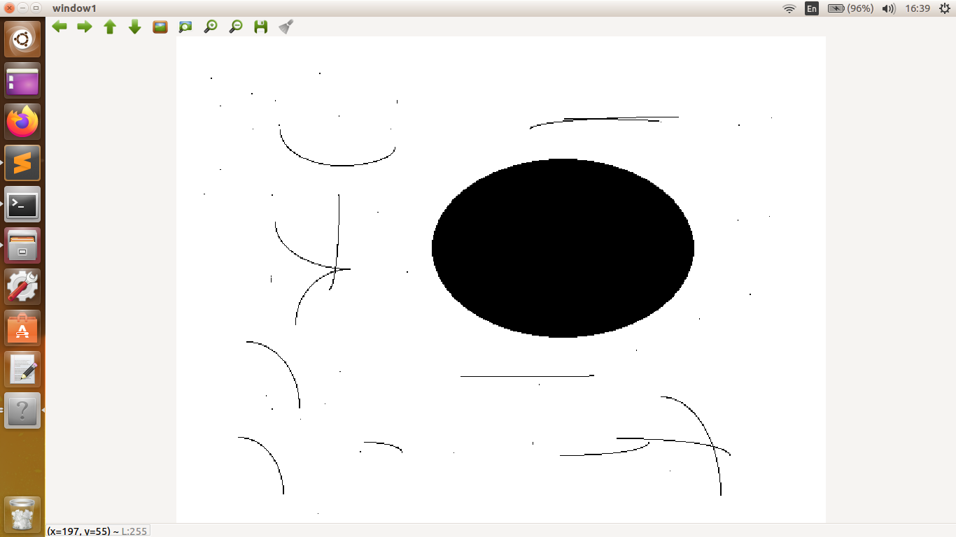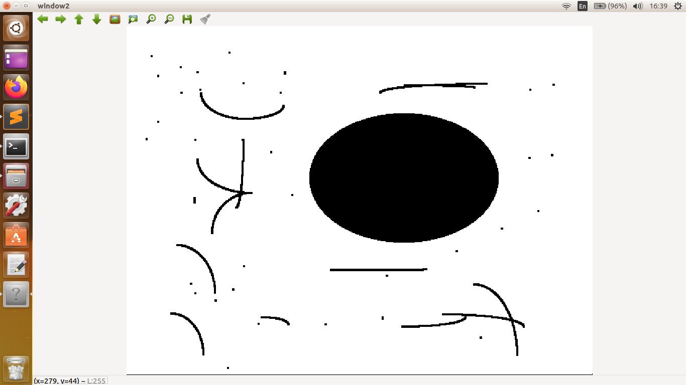

Original Image. Eroded Image.

Dilation- Similar to erosion, but it changes any black centre pixel into white if there is even a single white pixel lying inside the region kernel is scanning.

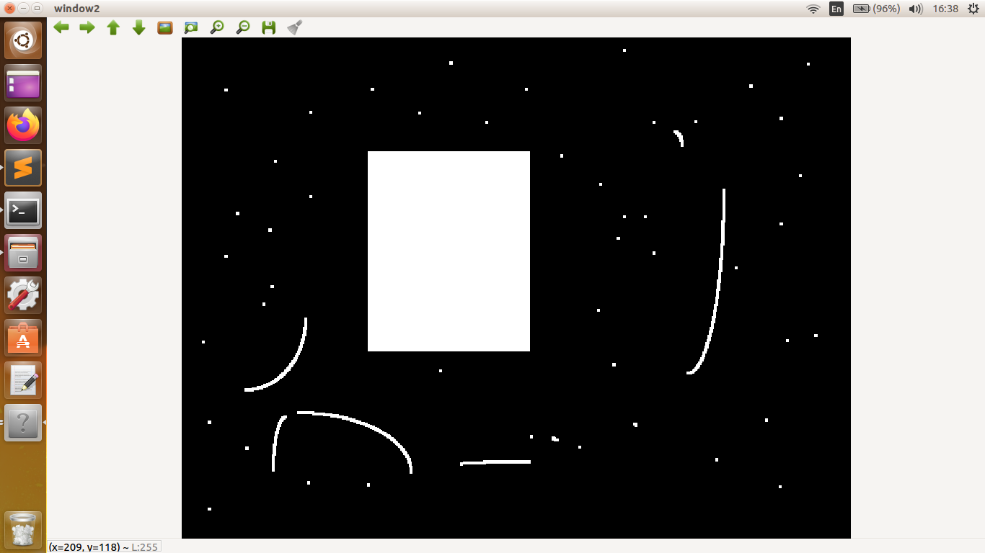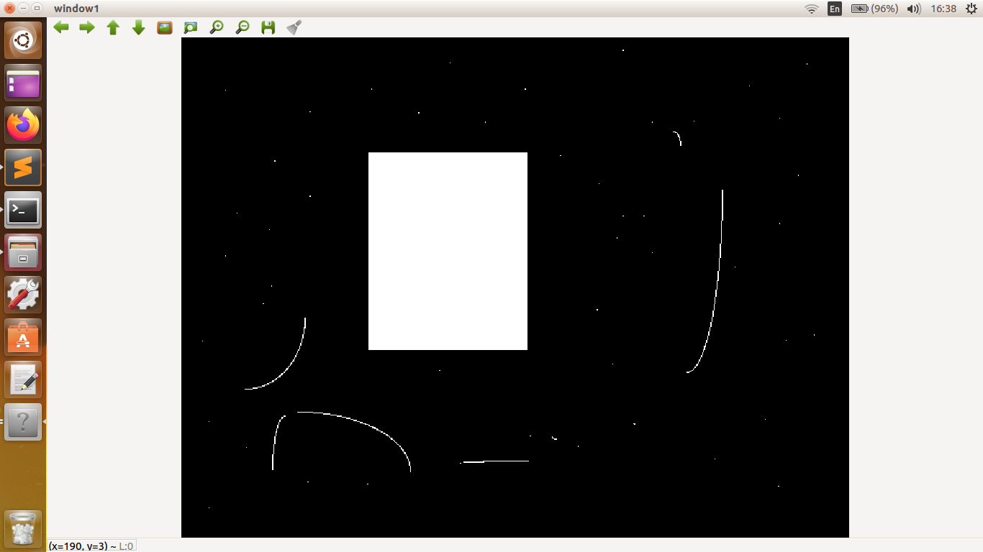

Original image. Dilated Image.

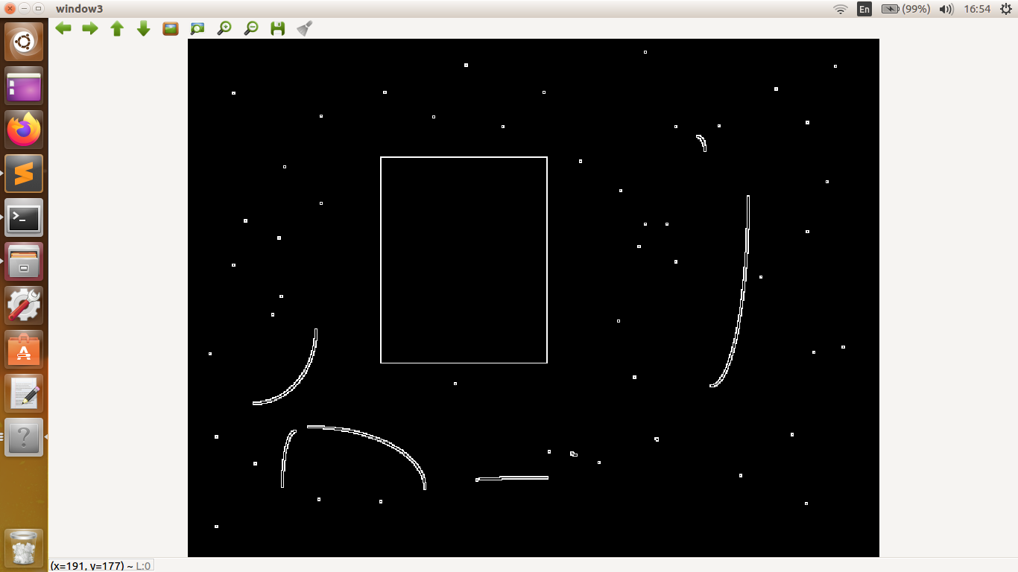

Edge, by subtracting images.

Convolution- Convolution is the process of adding each pixel lying inside kernel, weighted by the value of element of kernel lying above the pixel.

Blur- Blur is used for noise reduction in an image. It is done at the cost of sharpness and details. It is generally done by mean, median or gaussian filter.

Mean filter- When using mean filter we simply average out the values of pixels inside kernel and assign it to the centre pixel.

Median filter- Here we read all the values of pixel on which kernel is overlapping and take the median value among them, and assign it to the centre pixel. It is generally used is reduction of noise which is salt and pepper type.

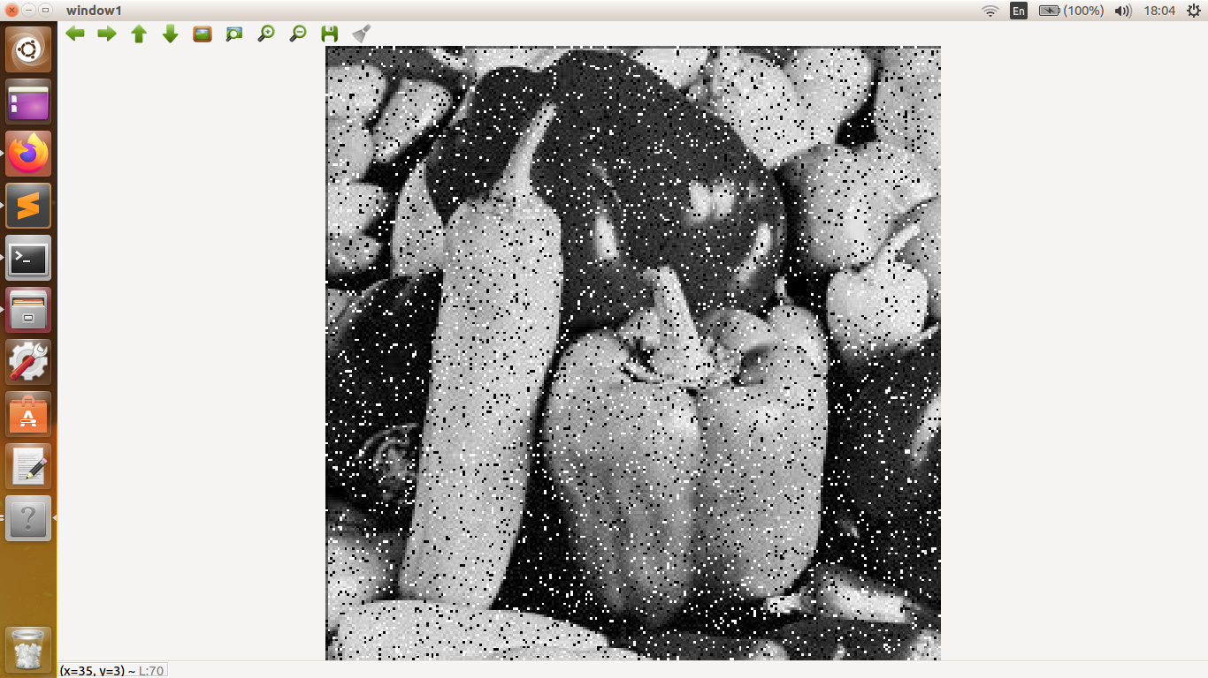

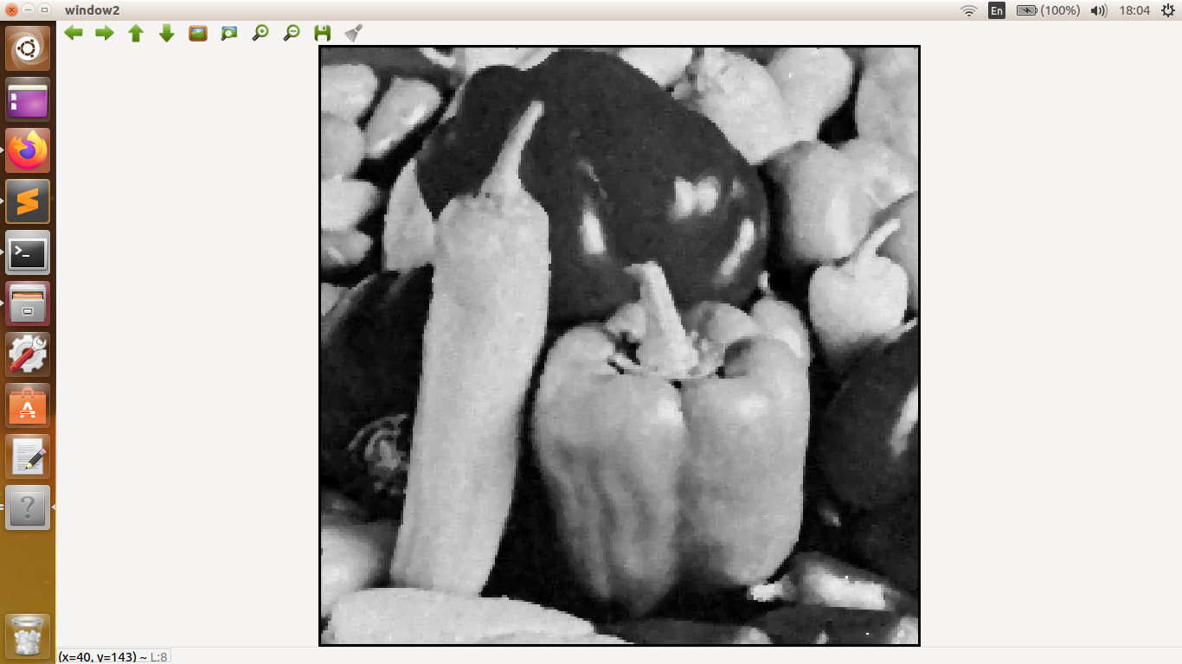

Original Image. After applying median blur.

Gaussian filter- It is a filter which has weights depending upon the distance of a pixel from centre. These weights are defined using gaussian function. Typically, they are in negative powers of 2. For example, a 3\*3 filter has weight of centre element as ¼, diagonal elements have weight 1/16, and rest have weight ⅛. It is used fo blurring an image.

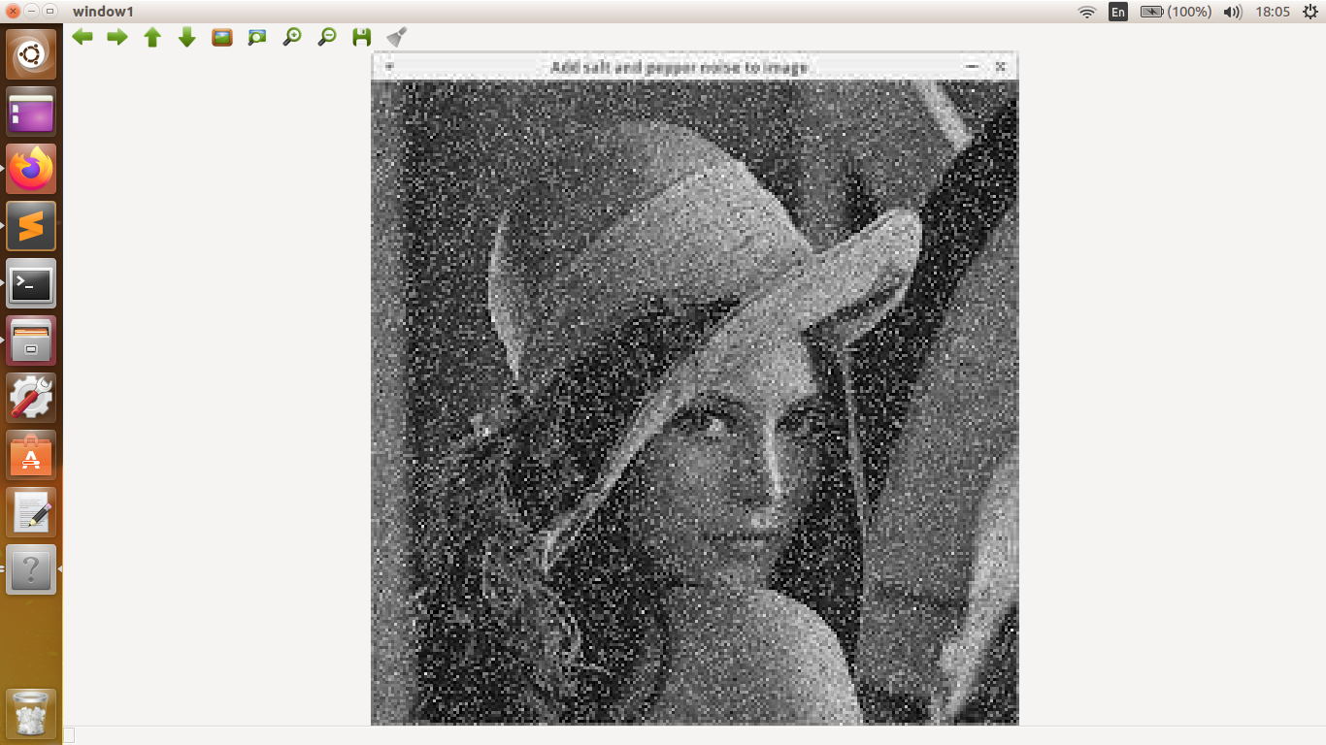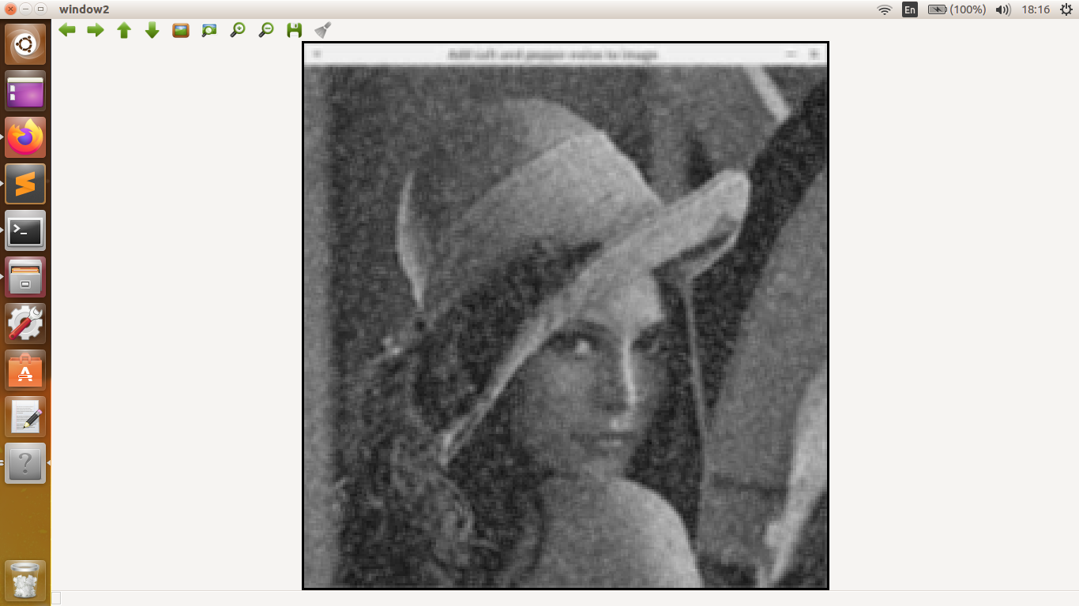

Original Image. After applying mean blur.

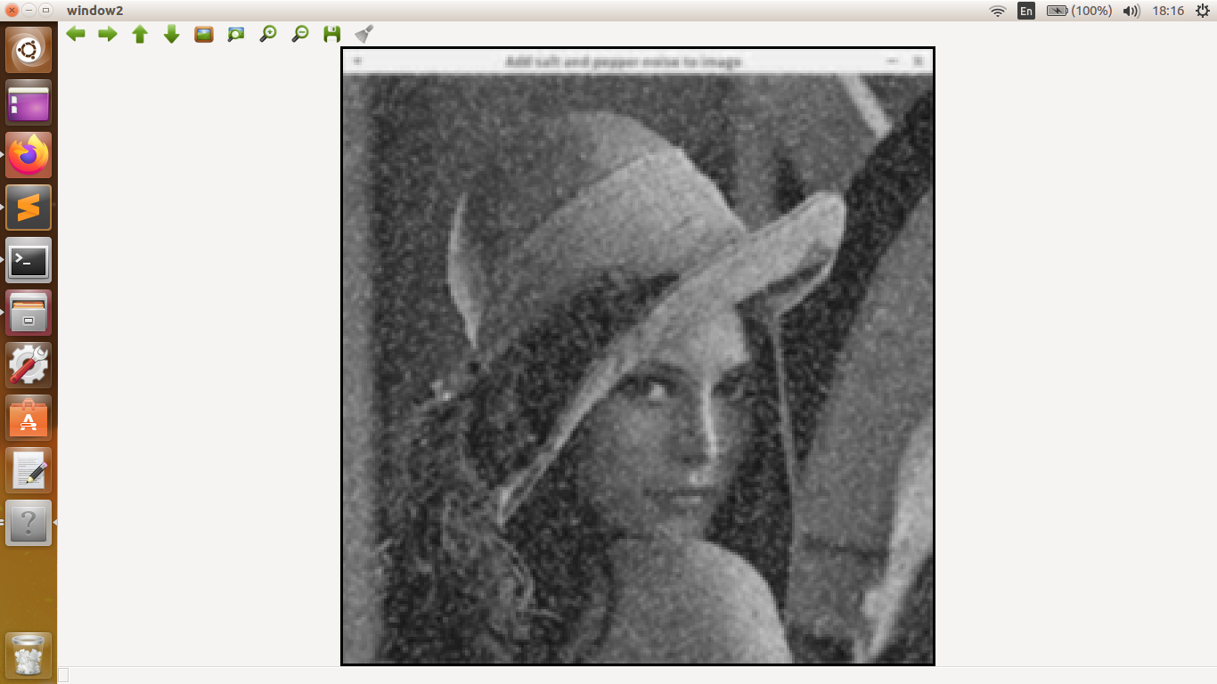

After applying gaussian blur.

Edge detection- To detect the edges in an image we use the concept of gradient. At edges there is sharp change in the intensity of colours, compared to other region. We use this property of the edges to dtect them using different operators. If the value provided by the opeator is greater than the certain threshold, we mark it as edge.

Prewitt operator- It is used for detecting vertical and horizontal edges. Weights are distributed so that the result of convolution is gradient.

Sobel operator- More advanced version of prewitt operator. The weight of pixels near centre is twice the that of diagonal.

Canny edge detection technique- It is a method comprising of several steps to get more refined edges.

Firstly, we apply gaussian blur on the image in which we want to detect edges. Next we find the values of sobel operator Gx, Gy and resulting gradient magnitude. From this gradient we extract edges.

But these edges are crude, and we may get bunch of lines around same place. So we travel in the perpendicular direction to the lines and find pixels with maximum gradient. We select those pixels and discard rest of

them. This is called non maximum suppression.

Next we compare these edges with upper and lower thresholds. If a line has gradient more than upper threshold. We assign it as edge. Next we check for lines with gradient values below upper threshold. If it is below lower threshold we reject it. If it is above lower threshold then we check wether this line meets the defined edges or not. If yes then it is an edge,otherwise we reject it.

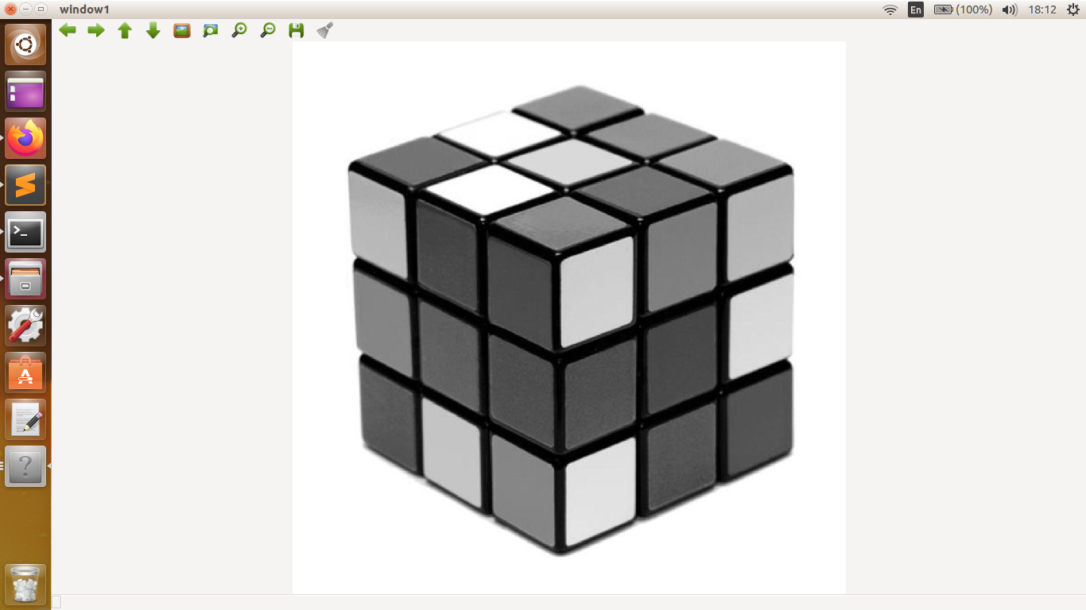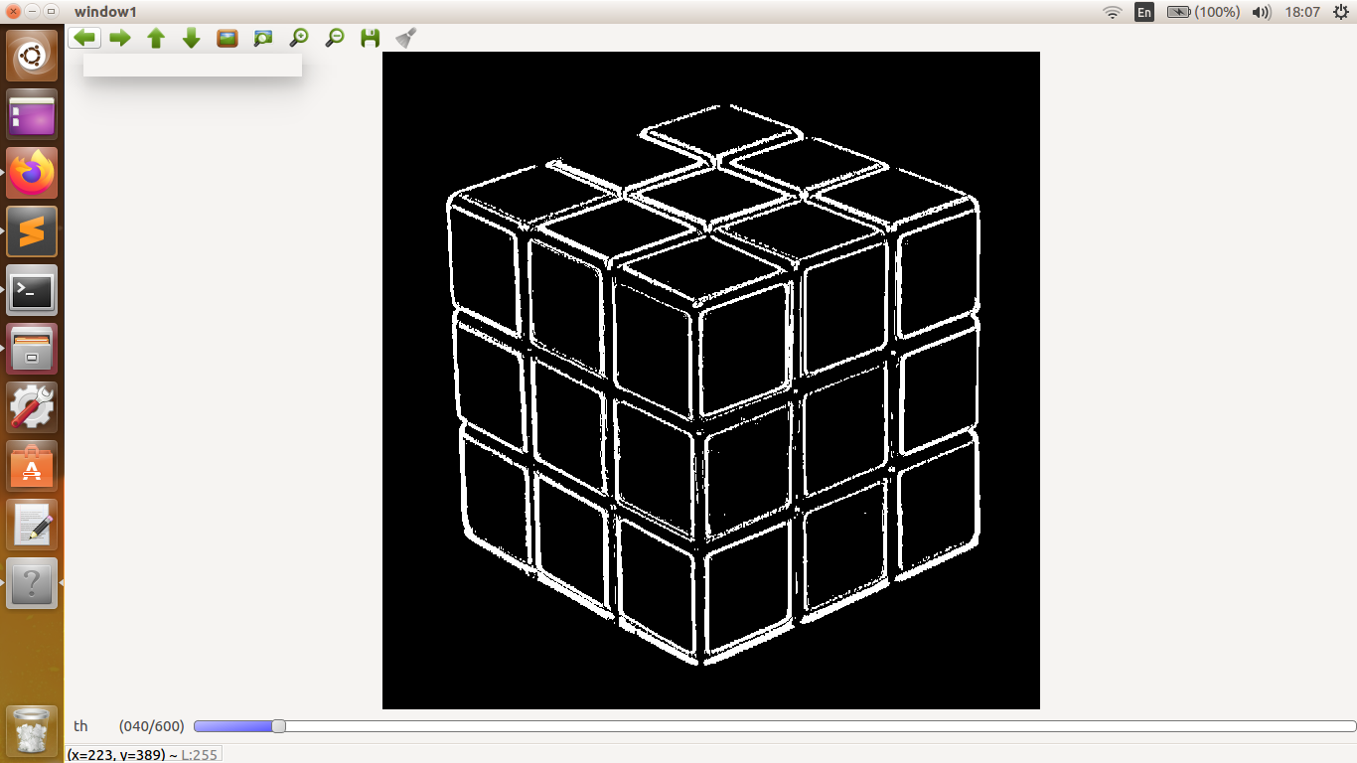

Original Image. Edge detection by sobel.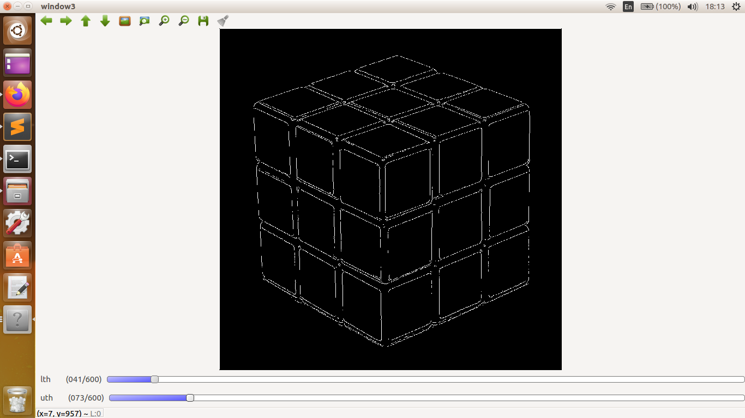

Edge detection using canny function.

Histogram- It is the plot of number of occurrence of given intensity in an image. An image with average distribution is high contrast, and localised

distribution has low contrast.

Day 4- 2 DEC

Trees, graphs and how to find shortest path using greedy approach. Dijkstra- implementation of greedy approach.

Nodes-Node is generally a point containing some information.

Child- Node connected to parent node.

Tree- Tree is connection of nodes in which there is no loops, i.e you cannot go back to a node which you earlier visited without retracing your path.

Graph- Graph is similar to tree except that it can have have loops.

We are generally interested in exploring a graph or a tree to access information. This can be done in 2 ways, Breadth first(bfs) or depth first search(dfs).

Breadth first search- As the name suggest, we first check all the childs of a node and then move on to explore other nodes. Queues are used to implement it.

Depth first search- Here we start traversing from parent node and go to one of the child, ignoring others. Then we go to the child of the node which we are currently occupying. We do this until we reach a dead end. Then we retrace our path and in that process if any node has more child, we again start exploring that branch. Stacks or recursion is used for this purpose.

Shortest path between two nodes(greedy approach)- In greedy approach, we initialise distance of each node from starting node to be infinity. Using bfs we keep exploring child of selected node, assigning them distance from source node and we choose the next parent node which has the least weight, marking it as visited. For some node if we find that weight is less in the current path we update the parent of that node, with current parent node.

Dijkstra- It is the function used to find shortest path between 2 pixel in an image. Greedy approach is used in implementing this code.

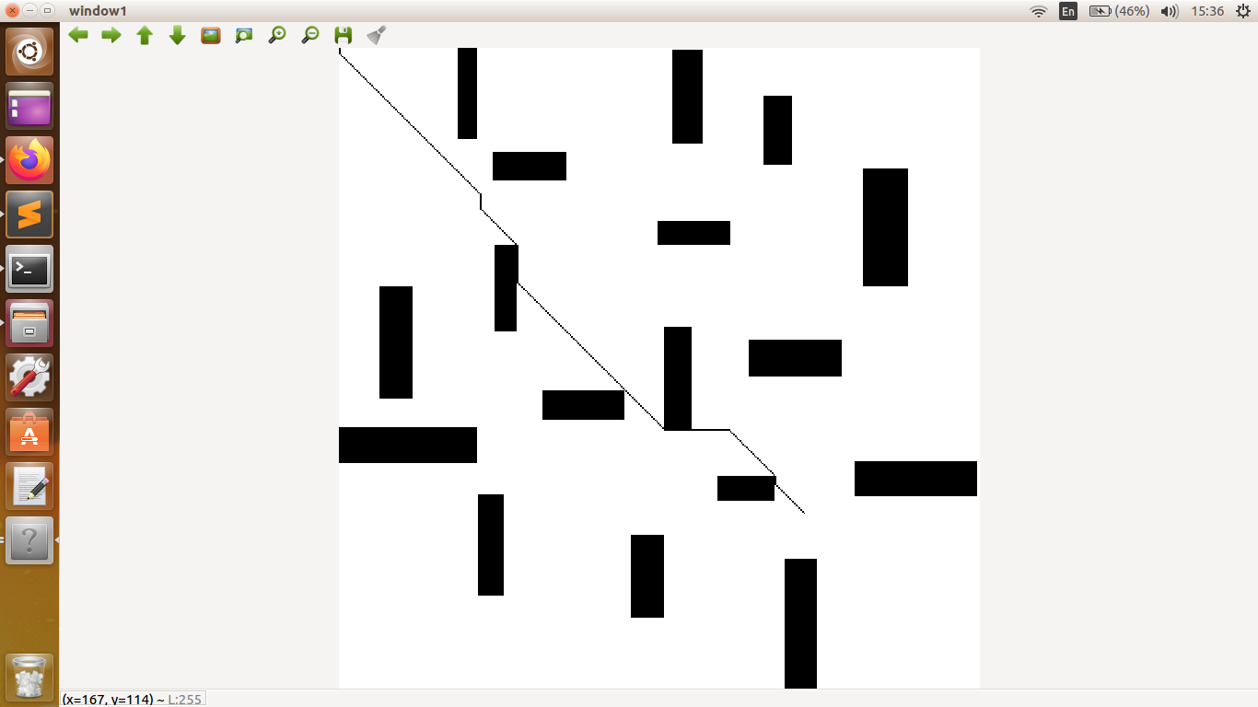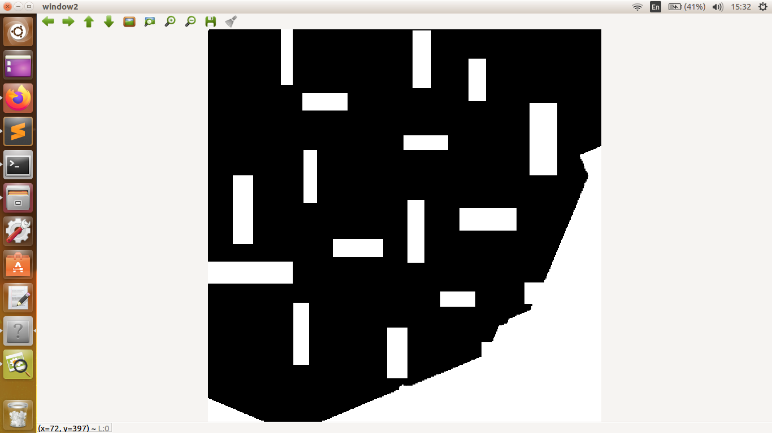

Growth of Djikstra in all direction. Final shortest path.

DAY 5- 3 DEC

Image transformation, histogram equalisation, Line detection in binary image, Contours, A\* algorithm, RRT.

Image transformation- Here we use some transform function T to change intensity r of pixel to s given by s= T(r);

Transform function can be many types-

1. Log transform- s=clog(1+r)
2. Power transform- s= cr^Y
3. Negative- s=c(255-r)

Histogram equalisation- We use it to change low contrast image to high contrast image.

s= ( L-1)ΣPr(r)

Where Pr(r), is current probability of finding r intensity in an image.

L is total number of intensity.

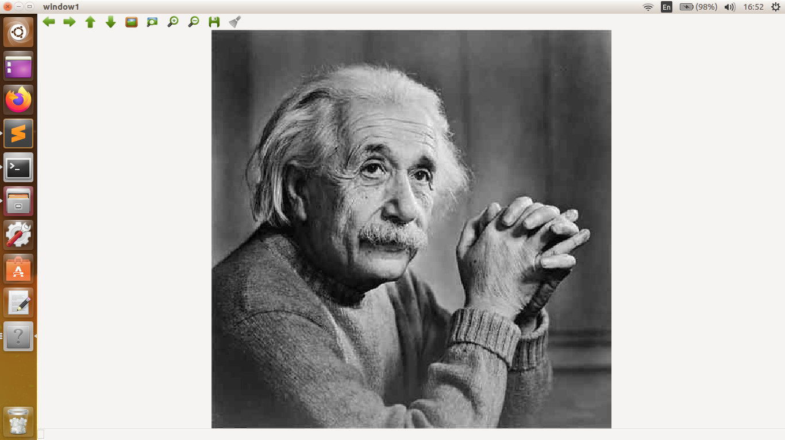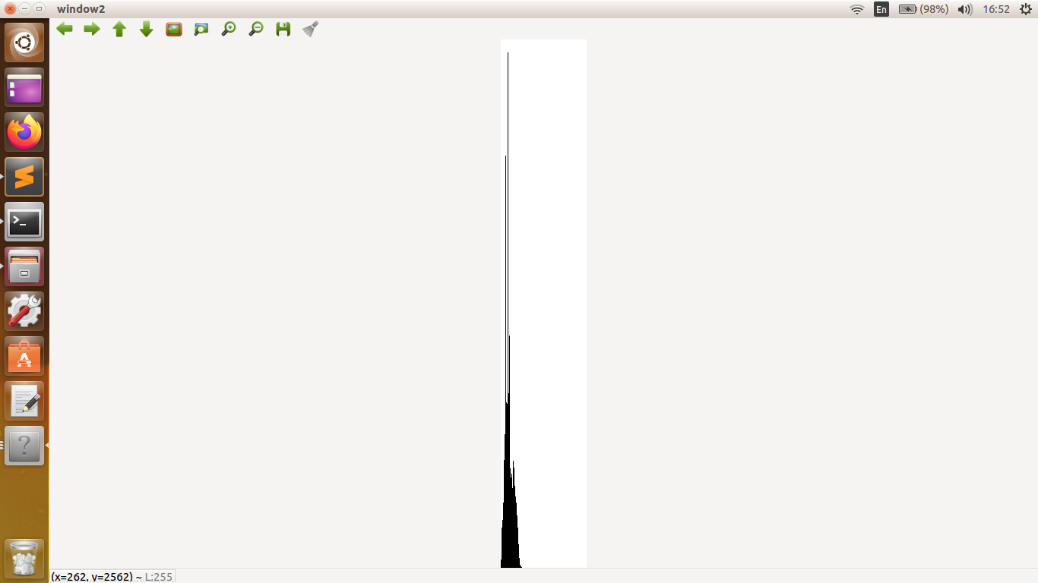

Original image. Histogram of original image.

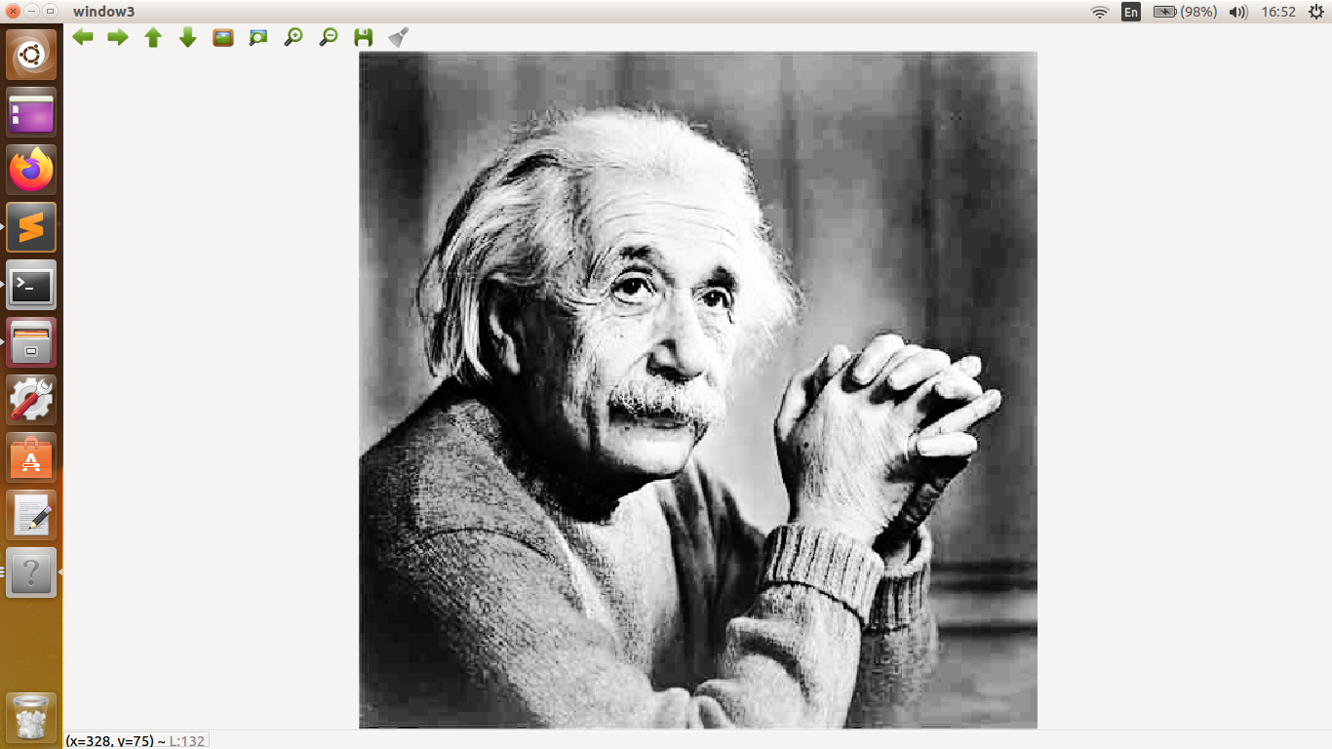

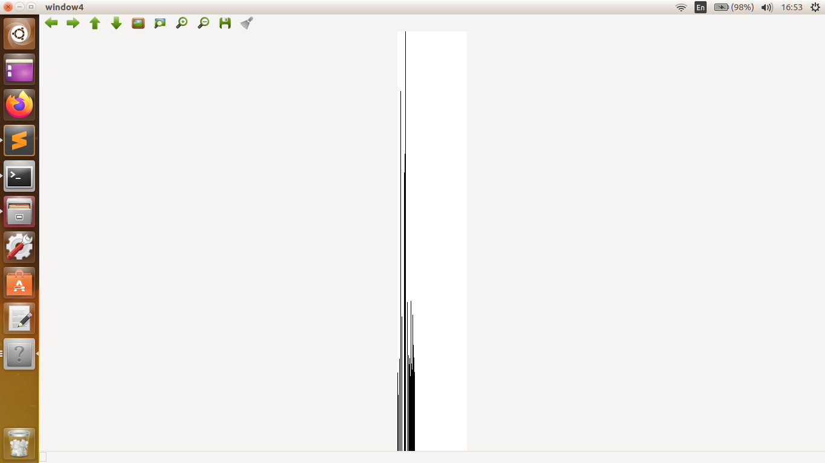

After histogram equalisation. Intensities become more even.

\*Height of both histograms are not same. It seems like that because maximum values in histogram defines maximum height of image.

Line detection- In a binary image we can detect lines by making each point vote for all the family of lines that pass from them. We use the perpendicular distance from origin and angle of line w.r.t x axis to identify the line. A line passing through (x,y) at an angle 𝛳 has perpendicular distance given by, r=xcos(𝛳)+ysin(𝛳). A line has constant r and 𝛳. Pixels on a line will vote again and again for that line and by thresholding the votes we can get the line.

HoughLines function can be used to detect a line.

Contour- It is a shape whose boundary distinguishes the pixels with different intensity. findContour is used to detect contours in an image and drawContour is used to draw them.

A\* algorithm- More efficient version of djikstra algorithm. Here we assign heuristic weights to each node in graph. We add the heuristic weight in the current path and then select which node should be chosen to progress through the path.

Heuristic weight- Estimated weight that will be added to the path if we go through the given node.

In an image, we generally choose euclidean distance as heuristic weight.

RRT(Rapidly Exploring Random Tree)-In this approach we generate a random point in an image and travel a unit distance in the direction of random point from node closest to it if no obstacle is present in path. We keep doing this until we reach within a certain range of the destination. After that we directly join the last node to destination. It is cfaster ths other algorithms, but path is not short.

Detection of red patch in video input and drawing its contour.

HSV colour format should be used as it gives more consistent result in different lighting condition.

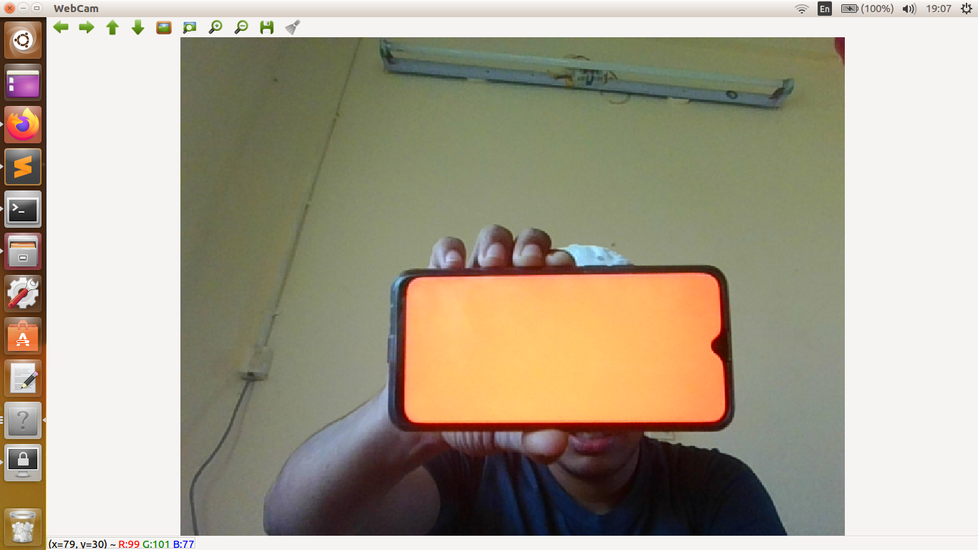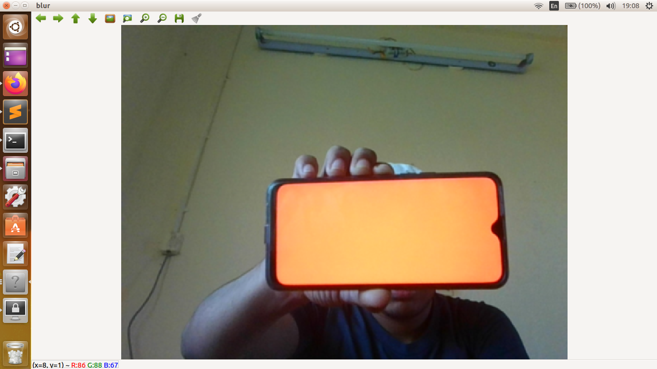

Input through webcam. Applying gaussian blur to input.

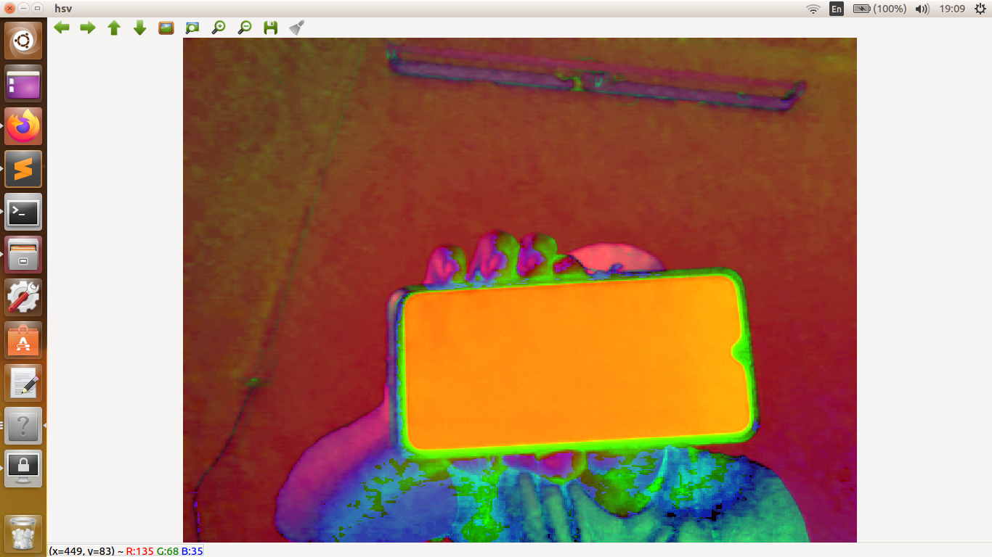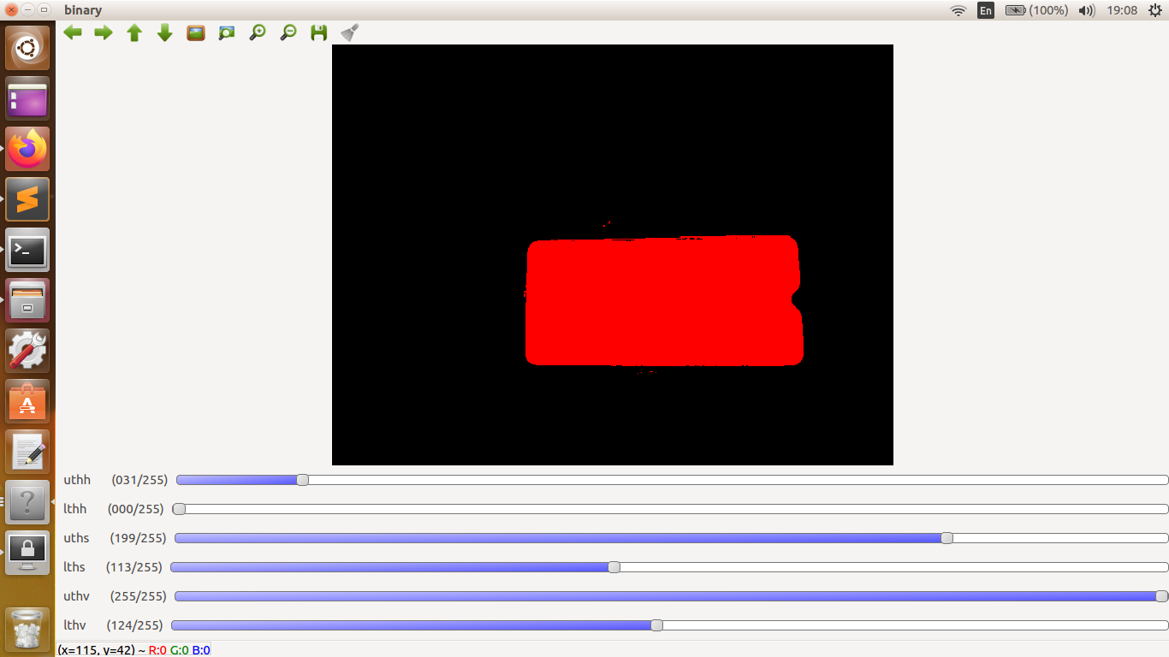

Converting blurred image to hsv. Extracting desired part using thresholding.

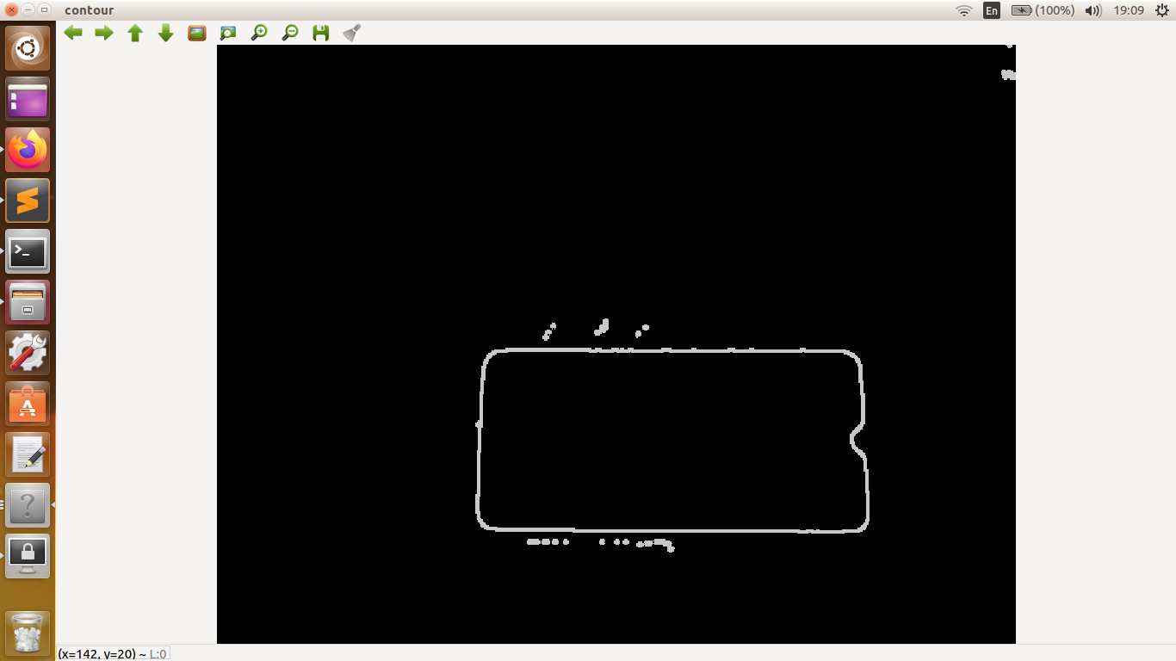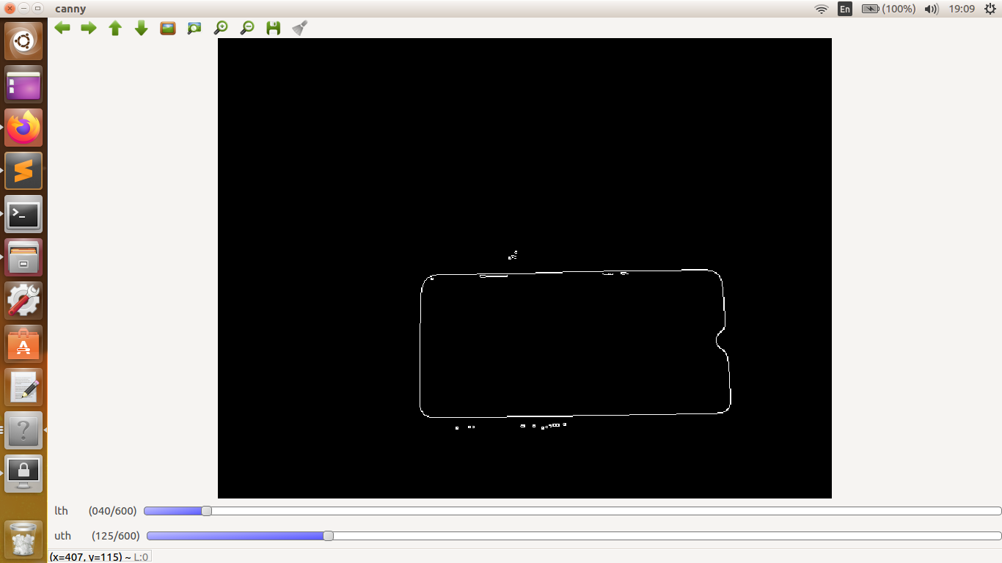

Applying canny. Detecting and drawing contour.

DAY 6- 4 DEC

Homography was taught and doubts were discussed.

Homography-It is used if we want part of an image covers the whole area of image. Homography governs the transformation of points.

findHomography and wrapPerspective functions are used for this purpose.

DAY 7- 5 DEC

Arduino was taught.

Arduino is used to give command to bots using programs running on a computer.(i wasn’t able to completely understand it.)

USEFUL LINKS- Details about every function used can be found on https://docs.opencv.org/2.4/index.html